1. Create account in github.
2. I or theshan can invite members based on github username or email.
3. You will receive an invitation like below to the mail used to create the github account.

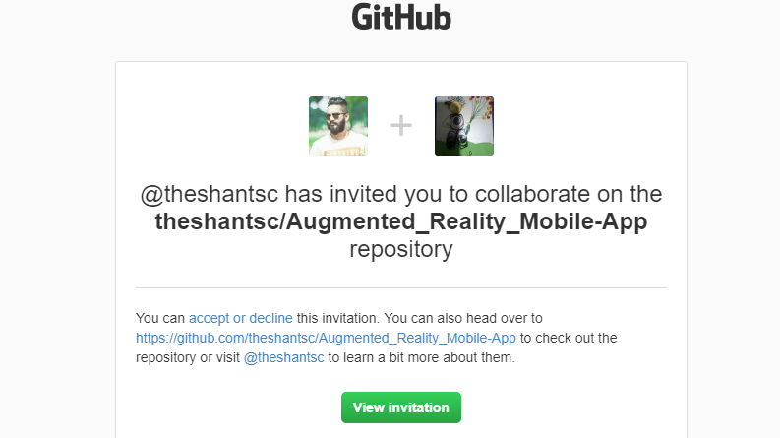

1. Accept the invitation>> Allow in next step too.

Kanchana

@Software Chasers